LAB Manual

PART A

(PART A: TO BE REFFERED BY STUDENTS)

**Experiment No: 9**

**A.1 Aim:**

To trace the email path from sender's location to recipient’s mail server using email header.

**A.2 Prerequisite:**

Fundamentals of IP address, email.

**A.3 Outcome:**

**After successful completion of this experiment students will be able to** 1. Trace email path from sender to receiver

2. to track email sender’s identity.

3. to track Internet Service Provider level

**A.4 Theory:**

What Is Email Tracing ?

This is the process of recovering key components of a message, usually located in the properties or header of the email. By obtaining the IP address of the email, you can get some info including the name of the individual or company responsible for sending the message.

Email Header:

The email header contains information about the email such as sender, recipient(s), subject, arrival date/time, attachments, and routing path of email message from the sender to the recipient. Not all email has proper email header which allows you to trace back to the original sender.

Gmail Email Header:

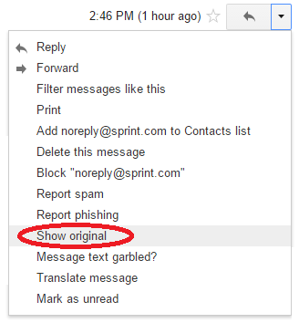

Outlook Email header

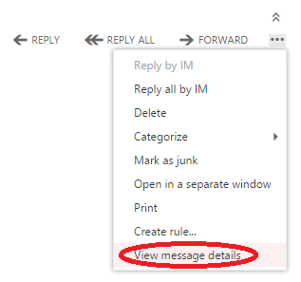

**Task:**

Find out

1. IP address of sender
2. Contact Information of ISP
3. Path of the email
4. Country /area code of sender
5. Latitude and Longitude

Some online email tracking websites:

1. https://cyberforensics.in/OnlineEmailTracer/index.aspx?AspxAutoDetectCookieSupport=1
2. <https://www.ip2location.com/free/email-tracer>
3. https://whatismyipaddress.com/trace-email

PART B

(PART B : TO BE COMPLETED BY STUDENTS)

***(Students must submit the soft copy as per following segments within two hours of the practical. The soft copy must be uploaded on the Portal or emailed to the concerned lab in charge faculties at the end of the practical in case the there is no portal access available)***

|  |  |
| --- | --- |
| Roll. No.: N049 | Name: Tarun Tanmay |
| Class: MBATech | Batch: B3 |
| Date of Experiment: | Date of Submission: |
| Grade: | |

**B.1 Theory written by student:**

**Email- Tracking**:

1. Email tracking is a method for monitoring the delivery of email messages to the intended recipient. Most tracking technologies use some form of digitally time-stamped record to reveal the exact time and date that an email was received or opened, as well the IP address of the recipient.

2. Mail tracking is legal under GDPR if your organization complies with GDPR. Compliance depends on your organization relationship with the recipients of your emails. For example, under new GDPR you may ask for a new consent to receive a newsletter or not, depending on the legitimate interest of this communication.

3. Email tracking notifies you when any email you sent has been opened or clicked. Email tracking software places an invisible image pixel in your emails that can detect the exact time and date an email has been opened by a recipient.

**B.2 Input and Output:**

1. **IP Address:** 209.119.0.3
2. **Mobile Network Code (MNC)** 004/005/006/012
3. **Path** Maryland to New York
4. **Mobile Country Code** **(MCC)** 310
5. **Coordinates** 40.714270, -74.005970 (40°42'51"N 74°0'21"W)

**B.3 Observations and learning:**

Through online medium we have traced the sender’s address who has sent the mail.The latitude, longitude, mobile network code, and Ip address of the sender.

**B.4 Conclusion:**

Through this experiment we have learned how to track address of the sender who has sent us the mail.